* [CoronaVirus](https://towardsdatascience.com/how-to-track-covid-19-cases-in-the-united-states-in-python-9b297ff9f6f5)
  + nice layout
  + interactive Map
* [TA Crypto Dashboard](https://medium.com/analytics-vidhya/building-a-dashboard-app-using-plotlys-dash-a-complete-guide-from-beginner-to-pro-e7657a4eb707)
  + datatables
  + oath login etc
* [Dash dbc Accordion collapse](https://medium.com/swlh/dashboards-in-python-for-beginners-using-dash-responsive-mobile-dashboards-with-bootstrap-css-2a0d05a53cf6)
  + 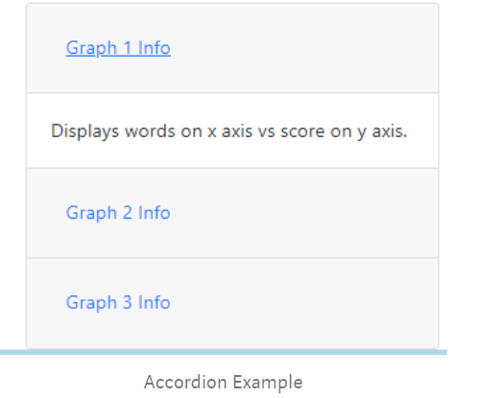
* [Dash code broken into sections](https://github.com/bendgame/DashApp/tree/master/wineDash)
* <https://medium.com/swlh/dashboards-in-python-3-advanced-examples-for-dash-beginners-and-everyone-else-b1daf4e2ec0a>